Chapter 1
INTRODUCTION
The amount of Medical data recorded in hospitals and its significance as an ever-growing source of information has been long known and proven. Though the importance of the information hidden in these records has never been doubted, this data has mostly been used only for clinical purposes. Only recently has this been properly mined for valuable information to be used for research and to develop systems that assist the medical fraternity. Mostly, the systems that make use of this information are domain specific systems that predict diseases restricted to their area of specialization (like heart, brain etc.). But these systems are limited and are not applicable to the whole medical dataset. Our system uses this vast storage of information so that diagnosis based on this historical data can be made. This system aids medical diagnosis in the whole dataset by computing the probability of occurrence of a particular ailment from the medical data. The system mines the data using a unique algorithm which increases accuracy of such diagnosis by combining Neural Networks and Differential Diagnosis all integrated into one single approach. The strengths of kNN, Feed Forward algorithm, SOM, back propagation and P2P Grid Architecture are used to make the system unique and effectively enhanced symptoms.
  - Definitions
Technology has played an unquestionable role in helping the medical fraternity in various ways, from surgical imagery to x-ray photography. But when it comes to diagnosis, the process still requires a doctor’s knowledge. Medical diagnosis involves processing various variables, ranging from medical history, climatic conditions, blood pressure, environment and lots more. The number of variables counts upto the total variables that are required to understand the complete working of nature itself, which no model has successfully analyzed yet. To overcome this problem, Medical decision support systems are becoming more and more essential, which will assist the doctors in taking correct decisions. The system, making use of various techniques including KNN classification and Neural Networks, gives the possible diagnosis along with the set of most probable diseases which have similar symptoms. Conventional methods completely overlook various variables involved such as prevailing conditions, the build-ups resulting in the symptoms etc., due to sheer magnitude of available unknown variables.
Differential diagnosis is a process of differentiating two or more condition which shares similar signs or symptoms. This is based on a knowledge of the pathophysiology of the presenting signs and symptoms, and the natural history of various diseases and their causative agents. This process becomes cumbersome when the symptoms and the patient's history is complex. The challenges faced in the differential diagnosis are diagnosing the disease of the patient’s golden time and also keeping in account the vast knowledge of the symptoms.
Considering the above challenges in differential diagnosis we try to overcome them using machine learning. We create a knowledge base required for diagnosing the diseases and collect the patient’s data such as symptoms, history and map it to the most possible diseases. Thus helps in diagnosing faster and narrows down the focus area.

  - Project Outline
Chapter 1 : we propose a robust and reversible database watermarking technique, Genetic Algorithm and Histogram Shifting Watermarking (GAHSW), for numerical relational data. The genetic algorithm is used to select the best secret key for grouping database, where the watermarking can be embedded with balanced distortion and capacity. The histogram of the prediction error is shifted to embed the watermark with good robustness.
Chapter 2 : Database watermarking is a relatively new technique and embeds the message into database records that are often independent and discrete.

Chapter 2
REVIEW OF LITERATURE
2.1 System Study
A detailed study to determine whether, to what extent, and how automatic data-processing equipment should be used; it usually includes an analysis of the existing system and the design of the new system, including the development of system specifications which provide a basis for the selection of equipment.
2.2 Proposed Work
We presents GAHSW for reversible watermarking of relational databases. GAHSW improves the data quality and the watermark robustness. The main architecture of GAHSW is presented, It includes the following three major phases: (1) watermark preprocessing; (2) watermark embedding; (3) watermark extraction and data recovery.

    - Problem Statement
- The reversible watermarking scheme method is not robust against heavy attacks
- The auxiliary data that needs to be passed to users are very large;
- The watermark information is uncertain and needs to be obtained by the genetic algorithm, so that different databases have different watermark information;
- When dealing with integer data, the robustness of RRW is poor because β, which is used to watermark a feature, is a decimal.

2.2.2 Existing System
- The first reversible watermarking scheme for relational databases was proposed in 2006, where histogram expansion is used for reversible database watermarking. However, this method is not robust against heavy attacks.
- In 2008, the technique called Difference Expansion based Watermarking (DEW) was utilized to watermark a database in a reversible way.
- Bhattacharya and Cortesi proposed a method in 2009 to embed the watermark after partitioning tuples as a permutation. However, when taking the distortion constraint into account, the embedding rate of DEW is greatly reduced.
- In the genetic algorithm (GA) was used to design a robust steganographic method.
- In , a new reversible database watermarking method is proposed by combining DEW with firefly algorithm (FFADEW). Best attribute values are selected by the FFA to yield lower distortion and increase watermark capacity.
- Another reversible watermarking technique proposed in, Prediction-Error Expansion Watermarking (PEEW), is fragile against malicious attacks because the watermarking information is embedded only in the fractional part of numeric features. For integer values, this method violates the imperceptibility of the watermarking.
- A Robust and semi-blind Reversible Watermarking (RRW) technique for numerical relational data was proposed. In this method, the value of Mutual Information (MI) for each feature is calculated and the features with low MI are selected for watermarking.

2.2.3 Proposed System
We presents GAHSW for reversible watermarking of relational databases. GAHSW improves the data quality and the watermark robustness. The main architecture of GAHSW is presented, It includes the following three major phases: (1) watermark preprocessing; (2) watermark embedding; (3) watermark extraction and data recovery.
- The watermark preprocessing phase also consists of three parts, sorting the attribute column according to the attribute name, determining the semantic distortion range of the attribute column, and obtaining the approximately optimal secret key information through GA. The secret key is used for watermark embedding and extraction.
- The main focus of watermark embedding phase is to embed watermark information in such a way that ensures the usability and the imperceptibility of the watermarked database. We ﬁrst use GA to select the best secret key for grouping and then embed watermark information (in the form of binary) into database using the new proposed HSW technique.
- After the watermarking, the database is released on a communication channel that is assumed to be insecure. These data may suffer several malicious attacks in the attacker channel. The effectiveness of GAHSW is presented through robustness analysis. We analyze the bit error rate of extracted watermarks for well-known attacks, such as subset insertion, deletion and alteration. The watermark extraction and data recovery phase mainly comprises effective extraction of the embedded watermark and successful recovery of the original data.

  - Scope of the project
Database watermarking has become a hot research as the increasing demand of ownership protection when sharing database information. Traditional watermarking techniques make changes in the database, which greatly compromise the data quality. Reversible watermarking techniques are used to solve this problem because they can recover original data from the watermarked database and ensure data quality.

Chapter 3
SYSTEM REQUIREMENTS SPECIFICATION

  - Functional Requirements
The functional requirements for a system describe what the system should do. These requirements depend on the type of software being developed, the general approach taken by the organization when writing requirements. The functional system requirements describe the system function in detail, its inputs and outputs, exceptions and so on.
Functional requirements are as follows :
- Create an desktop application.
- Collect the database.
- Short the attributes.
- Generate the secret key using genetic algorithm.
- Embed the watermarking bits.
- Data recovery from the embed bits.
- Application should provides high security using the watermarking scheme for the database.
.
  - Non-Functional Requirements
Non functional requirements, as the name suggests, are requirements that are not directly concerned with the specific functions delivered by the system. They may relate to emergent system properties such as reliability, response time and store occupancy. Alternatively, they may define constraints on the system such as capabilities of I/O devices and the data representations used in system interfaces.
The non functional requirements are as follows :
- The program must be self-contained so that it can easily be moved from one Computer to another. It is assumed that network connection will be available on the computer on which the program resides.
- Capacity, scalability and availability.
The system shall achieve 100 per cent availability at all times.
The system shall be scalable to support additional clients and volunteers.
- Maintainability.
The system should be optimized for supportability, or ease of maintenance as far as possible. This may be achieved through the use documentation of coding standards, naming conventions, class libraries and abstraction.
- Randomness, verifiability and load balancing.
The system should be optimized for supportability, or ease of maintenance as far as possible. This may be achieved through the use documentation of coding standards, naming conventions, class libraries and abstraction. It should have randomness to check the nodes and should be load balanced.

  - Hardware Requirements
- System : Intel P3.
- Hard Disk : 120 GB.
- Monitor : 15’’ LED
- Input Devices : Keyboard, Mouse
- Ram : 4 GB

  - Software Requirements
- Operating system : Windows 7.
- Coding Language : Python
- IDE : PythonIDLE

Chapter 4
SYSTEM DESIGN
4.1 Design Overview
The Design Summary allows you to quickly access design overview information, reports, and messages. By default, the Design Summary appears in the Workspace when you open a project, and it displays information specific to your targeted device and software tools.
4.2 System Architecture
The main architecture of GAHSW is presented in Figure 1. It includes the following three major phases: (1) watermark preprocessing; (2) watermark embedding; (3) watermark extraction and data recovery.
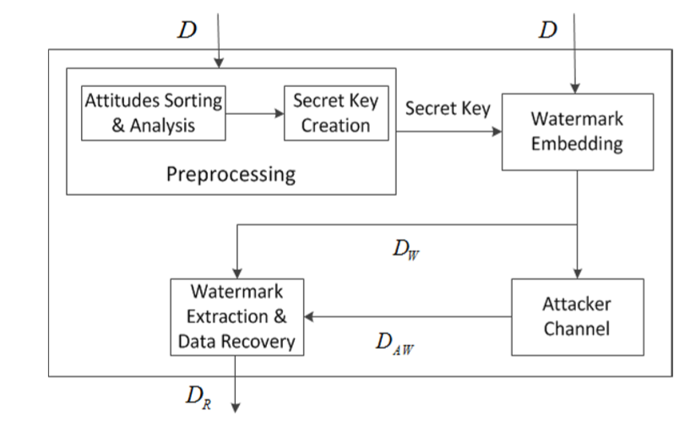
Fig 4.2 System Architecture

4.3 Data Flow Diagrams
4.3.1 Data Flow Diagram - Level 0
Level 0 describes the over all process of your project. It takes the input of database and perform the watermarking embedding using GAHSW model and provides the security.

0.1

Efficient provides security for database using GAHSW model
Database
secure database

Fig 4.3 DFD-Level 0

4.3.2 Data Flow Diagram - Level 1
Level:1 Describes the Initial step of our project. It takes the input of database and perform the shorting the attributes and generate the secret key using genetic algorithm.

Database
1.1

Short Attributes
1.2

Extract Features & Generate Secret key
Secret key and data
Attribute
Preprocess
sk and data

Fig 4.3 DFD-Level 1

4.3.3 Data Flow Diagram - Level 2
Level:2 Describes the final step of our project. It takes the input of data and secret key and perform watermarking using HSW and generates the watermarked database.
Data
Secret key
2.1

Read the Data
2.1

Read sk
2.2

Mark Watermarking Bits

Secure database
2.3

Apply Watermarking using HSW

Fig 4.4 DFD-Level 2

Fig 4.3 DFD-Level 2

4.4 Use Case Diagrams
A use case diagram in the Unified Modeling Language (UML) is a type of behavioral diagram defined by and created from a Use-case analysis. Its purpose is to present a graphical overview of the functionality provided by a system in terms of actors, their goals (represented as use cases), and any dependencies between those use cases. The main purpose of a use case diagram is to show what system functions are performed for which actor. Roles of the actors in the system can be depicted.

User

System

Original data
Load the Database

Read Data
Preprocess
Generate key
Watermark embedding

Key Verify
Data Recovery

Fig 4.4 Use case diagram

4.5 Class Diagrams
In software engineering, a class diagram in the Unified Modeling Language (UML) is a type of static structure diagram that describes the structure of a system by showing the system's classes, their attributes, operations (or methods), and the relationships among the classes. It explains which class contains information.

User

Database:varchar

Load database()
view the secure database()
View recovered data()
System

Database: varchar

Read Dataset()
preprocess()
keygen()
Embed watermark()
verify key()
Data recovery()

Fig 4.5 Class diagram

4.6 Sequence Diagrams
A sequence diagram in Unified Modeling Language (UML) is a kind of interaction diagram that shows how processes operate with one another and in what order. It is a construct of a Message Sequence Chart. Sequence diagrams are sometimes called event diagrams, event scenarios, and timing diagrams.

Original Data

Recovery()

Genkey()
EmbedWM()
Short Attrib()
Load DB()

User
System
Secure Data

Key()

Fig 4.6 Sequence diagram

4.7 Activity Diagrams
Activity diagrams are graphical representations of workflows of stepwise activities and actions with support for choice, iteration and concurrency. In the Unified Modeling Language, activity diagrams can be used to describe the business and operational step-by-step workflows of components in a system. An activity diagram shows the overall flow of control.
Load Data
Preprocess
Generate Key Using GA
Embedding Watermark Using HSW
Recover the original data

Fig 4.7 Activity diagram

4.8 Modules of the Project
- Preprocessing Phase
- Embedding Phase
- Extraction and Data Recovery Phase
4.9.1 Module 1
Module Name:- Preprocessing Phase
Functionality:-This function of data preprocessing is to make the watermark insertion/reading independent of the way the database is stored. One solution is to perform the tuple grouping operation prior to watermark insertion.
Three important tasks should be accomplished: (1) sorting the attribute columns; (2) determining the range of attribute values; (3) calculating an approximately optimal secret key string with the help of GA.

Input:-The financial database.
Output:-Actual system will load the database and short its attributes in ascending order according to the attribute names, the range of attribute values in each attribute column of the database, and calculate an optimal secret key using the GA algorithm to obtain the approximately optimal grouping for the database watermark., this optimal secret key and attribute values will be the input for the module 2.
Algorithm used : Genetic algorithm is used to generate optimal key from the range of attributes.

4.9.2 Module 2
Module Name:- Embedding Phase
Functionality:-In this Histogram shifting provides a novel approach to robust watermarking scheme for databases. In this scheme, all tuples are securely divided into non-overlapping subsets. A single watermark bit is embedded into some tuples of a subset by modifying attribute values in the group. A watermark bit is embedded repeatedly into one group. Input:- GA outputs the best secret key for grouping in the preprocessing phase.
Output: - Watermarked secure Image.
Algorithm used : Histogram Shifting(HS)

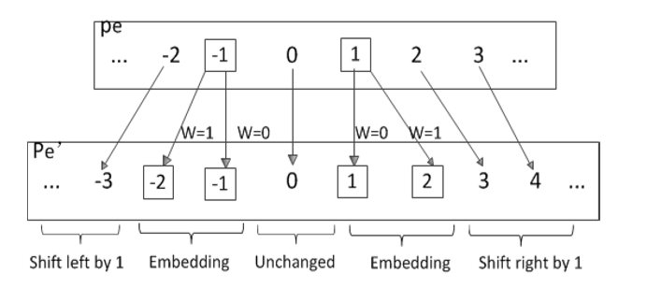

4.9.3 Module 3
Module Name:- Extraction and Data Recovery Phase
Functionality:- Concerning the watermark extraction stage, groups of tuples are constructed. Since the distribution of the hash function is identical when seeded by the same secret key, tuples are in the same groups as in the watermark insertion algorithm. Tuples are divided into Ng groups, which need the primary key and the secret key. It is important to remark that the secret key should be known by the detector so as to make it possible to reconstruct the groups. The peaks of each group, as well as the primary keys corresponding to the tuples where the selected attributes are prohibited be modiﬁed in the embedding phase, are sent to readers as a part of the watermarking key. Watermark bits extracting and the original attribute value recovery using the HS detection technique.
Input:-Watermarked secure image.
Output: - Original Data.

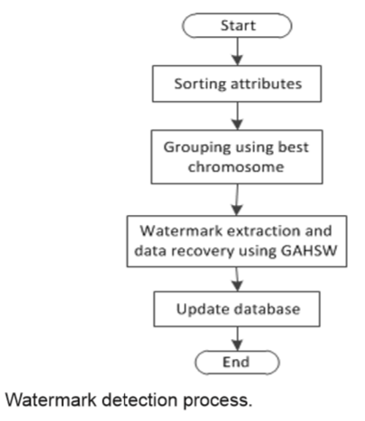

BIBLIOGRAPHY
[1] Y.-C. Liu, Y.-T. Ma, H.-S. Zhang, D.-Y. Li, and G.- S. Chen, “A method for trust management in cloud computing: Data coloring by cloud watermarking,” International Journal of Automation and Computing, vol. 8, no. 3, pp. 280–285, Aug 2011.
[2] M. McNickle, “Top 10 data security breaches in 2012 [online],” http://www.healthcarefinancenews. com/news/top-10-data-security-breaches-2012, 2013, Apr. 17.
[3] J. Kiernan, Chapter 15 - Watermarking Relational Databases, 2002.
[4] R. Halder and A. Cortesi, “A persistent public watermarking of relational databases,” in Information Systems Security - International Conference, Iciss 2010, Gandhinagar, India, December 17-19, 2010. Proceedings, 2010, pp. 216–230.
[5] M. J. A. R. Sion and S. Prabhakar, “Rights protection for relational data,” IEEE Trans. Knowl. Data Eng., vol. 16, no. 12, pp. 1509–1525, 2004.
[6] D. Gross-Amblard, “Query-preserving watermarking of relational databases and xml documents,” Acm Transactions on Database Systems, vol. 36, no. 1, pp. 1– 24, 2011.
[7] E. B. M. Shehab and A. Ghafoor, “Watermarking relational databases using optimization-based techniques,” IEEE Trans. Knowl. Data Eng., vol. 20, no. 1, pp. 116–129, 2008.
[8] R. Halder, S. Pal, and A. Cortesi, “Watermarking techniques for relational databases: Survey, classification and comparison.” J. UCS, vol. 16, no. 21, pp. 3164–3190, 2010.
[9] S. S. M. Kamran and M. Farooq, “A robust, distortion minimizing technique for watermarking relational databases using once-for-all usability constraints,” IEEE Trans. Knowl. Data Eng., vol. 25, no. 12, p. 2694C2707, 2013.
[10] M. Kamran and M. Farooq, “A formal usability constraints model for watermarking of outsourced datasets,” IEEE Transactions on Information Forensics and Security, vol. 8, no. 6, pp. 1061–1072, 2013.
[11] J. Franco-Contreras and G. Coatrieux, “Robust watermarking of relational databases with ontology-guided distortion control,” IEEE Transactions on Information Forensics and Security, vol. 10, no. 9, pp. 1939–1952,2015.
[12] Y. Zhang, B. Yang, and X. M. Niu, “Reversible watermarking for relational database authentication,” ŁXW, vol. 17, no. 2, pp. 59–65, 2006.
[13] G. Gupta and J. Pieprzyk, “Reversible and blind database watermarking using difference expansion,” 2008, pp. 1–6.
[14] S. Bhattacharya and A. Cortesi, “A distortion free watermark framework for relational databases,” in Icsoft 2009 - Proceedings of the International Conference on Software and Data Technologies, Volume 2, Soﬁa, Bulgaria, July, 2013, pp. 229–234.
[15] Y. Wu and F. Y. Shih, “Genetic algorithm based methodology for breaking the steg analytic systems,” IEEE Transactions on Systems Man & Cybernetics Part B Cybernetics A Publication of the IEEE Systems Man & Cybernetics Society, vol. 36, no. 1, pp. 24–31, 2006.
[16] K. Jawad and A. Khan, “Genetic algorithm and difference expansion based reversible watermarking for relational databases,” Journal of Systems & Software, vol. 86, no. 11, pp. 2742–2753, 2013.
[17] M. B. Imamoglu, M. Ulutas, and G. Ulutas, “A new reversible database watermarking approach with ﬁreﬂy optimization algorithm,” Mathematical Problems in Engineering,2017,(2017-3-6), vol. 2017, no. 2, pp. 1–14, 2017.
[18] M. E. Farfoura and S. J. Horng, “A novel blind reversible method for watermarking relational databases,” in International Symposium on Parallel and Distributed Processing with Applications, 2010, pp. 563–569.
[19] S. Iftikhar, M. Kamran, and Z. Anwar, “Rrwła robust and reversible watermarking technique for relational data,” Knowledge & Data Engineering IEEE Transactions on, vol. 27, no. 4, pp. 1132–1145, 2015.
[20] V. Khanduja, “Database watermarking, a technological protective measure: Perspective, security analysis and future directions,” Journal of Information Security and Applications, vol. 37, pp. 38–49, 2017.
[21] Y. Q. Shi, Reversible Data Hiding. Springer Berlin Heidelberg, 2005.
[22] G. Xuan, Q. Yao, C. Yang, J. Gao, P. Chai, Y. Q. Shi, and Z. Ni, “Lossless data hiding using histogram shifting method based on integer wavelets,” in International Conference on Digital Watermarking, 2006, pp. 323–332.
[23] C. C. Lin, W. L. Tai, and C. C. Chang, “Multilevel reversible data hiding based on histogram modification of difference images,” Pattern Recognition, vol. 41, no. 12, pp. 3582–3591, 2008.
[24] W. L. Tai, C. M. Yeh, and C. C. Chang, “Reversible data hiding based on histogram modification of pixel differences,” IEEE Transactions on Circuits & Systems for Video Technology, vol. 19, no. 6, pp. 906–910, 2009.
[25] D. G. Yeo, H. Y. Lee, and B. M. Kim, “High capacity reversible watermarking using differential histogram shifting and predicted error compensation,” Journal of Electronic Imaging, vol. 20, no. 1, pp. 40–43, 2011.
[26] H. T. Wu and J. Huang, “Reversible image watermarking on prediction errors by efficient histogram modification,” Signal Processing, vol. 92, no. 12, pp. 3000–3009, 2012.
[27] L. Luo, Z. Chen, M. Chen, X. Zeng, and Z. Xiong, “Reversible image watermarking using interpolation technique,” IEEE Transactions on Information Forensics & Security, vol. 5, no. 1, pp. 187–193, 2010.
[28] X. Gao, L. An, Y. Yuan, D. Tao, and X. Li, “Lossless data embedding using generalized statistical quantity histogram,” IEEE Transactions on Circuits & Systems for Video Technology, vol. 21, no. 8, pp. 1061–1070, 2011.
[29] X. Li, W. Zhang, X. Gui, and B. Yang, “A novel reversible data hiding scheme based on two-dimensional difference-histogram modification,” IEEE Transactions 2013, pp. 229–234.
[30] B. Yang, M. Schmucker, C. Busch, X. Niu, and S. Sun, “Approaching optimal value expansion for reversible watermarking,” in The Workshop on Multimedia and Security, 2005, pp. 95–102.
[31] G. Xuan, Y. Q. Shi, P. Chai, X. Cui, Z. Ni, and X. Tong, “Optimum histogram pair based image lossless data embedding,” in International Workshop on Digital Watermarking, 2008, pp. 264–278.
[32] J. Wang, J. Ni, X. Zhang, and Y. Q. Shi, “Rate and distortion optimization for reversible data hiding using multiple histogram shifting,” IEEE Transactions on Cybernetics, vol. 47, no. 2, p. 315, 2017.
[33] A. Khan, S. F. Tahir, A. Majid, and T. S. Choi, “Machine learning based adaptive watermark decoding in view of anticipated attack,” Pattern Recognition, vol. 41, no. 8, pp. 2594–2610, 2008.
[34] M. Yoo, “Real-time task scheduling by multi objective genetic algorithm,” Journal of Systems & Software, vol. 82, no. 4, pp. 619–628, 2009.

